Ontology landscape template for information collection
Note: At the end of this template, you find a draft of an overview visualization showing the ontology landscape, to which the ontology described will be added based on the provided information. You also find links to four examples for which the ontology information has been provided.
Note: an extensive analysis of ontologies for IoT is provided at https://lov4iot.appspot.com/?p=ontologies that can help when filling in this template (e.g., main concepts, ontology URL code or documentation, scientific papers and projects).

ONTOLOGY ACRONYM & FULL NAME

CREATOR(S) & ISSUING ORGANIZATION(S)

MOST RELEVANT URLs & OTHER PRECISE REFERENCES
- Technical specification/documentation of the ontology
- Persistent URI of the ontology file
- Research paper describing the ontology (the most relevant)

ONTOLOGY AVAILABILITY
- Is the ontology implemented in the OWL language? (Yes/No)
- Does the ontology have a license? (Yes/No) What is the license of the ontology? Is it an open license? (Yes/No)
- Is the ontology available online following the semantic web best practices? (Yes/No)
- Does the ontology publication support content negotiation for at least HTML and one OWL serialization? (Yes/No)
- Is the ontology registered in some ontology catalogue? (Yes/No)

DOMAIN OF INTEREST
Use the domains in the template at the end of this document as a basis. Domains of interest include, but are not limited to: Smart Home/Building, Industry, Mobility, Health, Energy, Cities, Wearables, Farming/Agrifood, Water/Environment

OVERALL DESCRIPTION (max 200 words)
In which context and projects the ontology has been developed

DESCRIPTION OF MAIN CONCEPTS (max 20 concepts)
Optionally, a figure depicting the main concepts can be used

MATURITY
An evaluation of the maturity of existing solutions based on the considered ontology.
The Technology Readiness Levels (TRL) are used for this purpose, which are also used in the European H2020 projects. Note that the TRL requested is related to the validation of the ontology in applications, e.g. an ontology that has only been used in a lab setting would still be considered TRL4, whereas an ontology validated in an operational environment would be TRL 7. Please provide a short explanation to justify the chosen TRL based on practical examples of implementations (max. 3). Only solutions on TRL4 and above are going to be considered here.
TRL 1 – basic principles observed
TRL 2 – technology concept formulated
TRL 3 – experimental proof of concept
TRL 4 – technology validated in lab
TRL 5 – technology validated in relevant environment (industrially relevant environment in the case of key enabling technologies)
TRL 6 – technology demonstrated in relevant environment (industrially relevant environment in the case of key enabling technologies)
TRL 7 – system prototype demonstration in operational environment
TRL 8 – system complete and qualified
TRL 9 – actual system proven in operational environment (competitive manufacturing in the case of key enabling technologies; or in space)

ADOPTION (max. 100 words)
- Is the ontology adopted by the industry and used in practice?
- Are there relevant communities behind it (industry, standardization, research)?
- Is it supported by standards, which?
Provide links if possible.

ALIGNMENT WITH OTHER ONTOLOGIES & REUSE (max. 150 words)
- Have the authors of this ontology aligned/mapped it to other existing ontologies (if any) of similar scope?
- Did the creators perform an appropriate reuse or extension of suitable high-quality ontologies?
- Have upper ontologies been extended?
- Have ontology design patterns been used?
- Has this ontology been used by other ontologies?

SUSTAINABILITY & MAINTAINABILITY (max. 100 words)
- Is there a community maintaining the ontology? Is there a sustainability plan?
- Is there a plan for the medium and long-term maintenance of the ontology?

There can be different levels, starting from an individual person committed to the maintenance, to a professional organization such as a standardization body:
Level 1 - a single maintainer (an individual and/or a project)
Level 2 - an organization
Level 3 - a group of organizations
Level 4 - a standardization body (member-based organization)

USE CASES (optional) (max. 200 words)
What are the use cases supported by the ontology?

Overview of Ontologies
Below is the planned high-level visualization of the ontologies. We may add additional views to cover additional aspects.

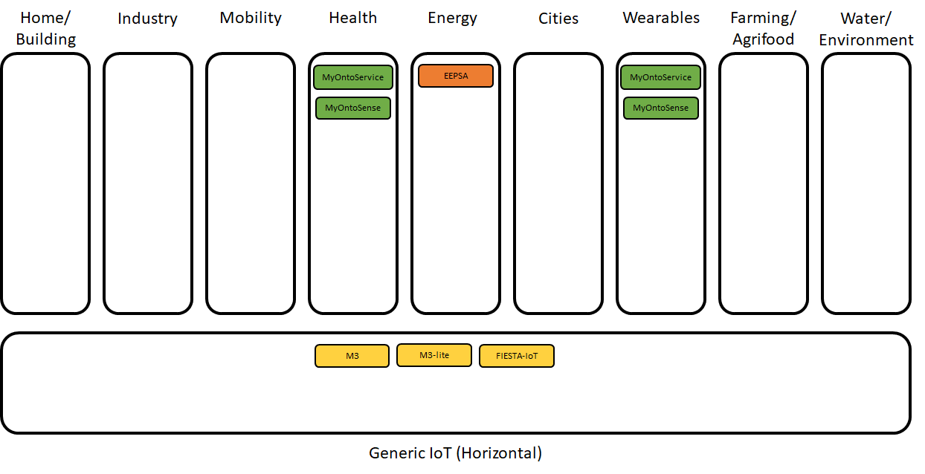
Below is the colour scheme used for the ontologies in the landscape, indicating both the sustainability and maintainability level, as well as the technology readiness level.
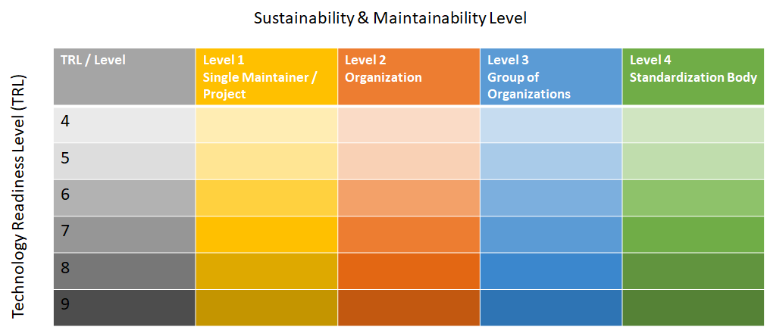

Examples of filled-out ontology templates

- Template applied to M3, M3-lite and FIESTA-IoT ontologies: https://docs.google.com/document/d/1T8lce6pn5VW5VlXUKK6nWzG5MwCGA4GHEhWKZOGIb0k
- Template applied to the EEPSA ontology: https://docs.google.com/document/d/1XUfrC6EnNx_pPWhZ4FPaqH6djVplgPsOeqcWkkzNO-k
- Template applied to ETSI SmartBAN Reference Model and associated modular ontologies: https://docs.google.com/document/d/1FgxRUJ_s5Fo4aKQhwC6omaDz1v9S9piwwzjlHD3SlmM
- Template applied to Perception and Manipulation Knowledge (PMK) ontology based on the IEEE 1872 Core Ontology for Robotics and Automation (CORA): https://docs.google.com/document/d/1d1b2ZS7y_-AbAmfXKoUcjgi0aae58B_G6NhRFwtKGH4

